**How does Create/Update/Delete works?**

# **The Cassandra Query Language (CQL)**

The Cassandra Query Language (CQL) is the primary language for communicating with the Apache Cassandra database. The most basic way to interact with Apache Cassandra is using the CQL shell, cqlsh. Using cqlsh, you can create keyspaces and tables, insert/update/delete and query tables, plus much more.

### **Create Operation**

Once you created keyspaces. Creating a new table uses the CREATE TABLE statement:

For example, here are some CQL statements to create tables:

Syntex:

| Create table KeyspaceName.Tablename(ColumnNme1 datatype1,ColumnName2 datatype2, primary key (columnName)); |
| --- |

### **Example**

Here is the snapshot of the executed Cassandra create table query that will create a table in Cassandra keyspace cluster1.

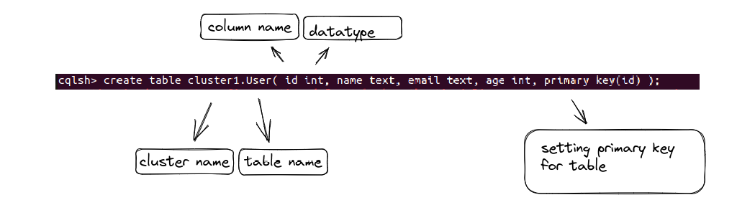

| create table cluster1.User( id int, name text, email text, age int, primary key(id) ); |
| --- |

If the query executed successfully then gonna see something like this

Here is the snapshot of the current database state.

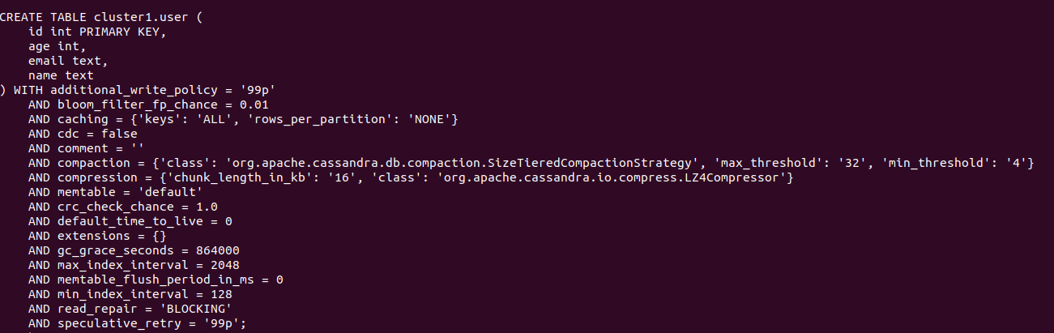

### **Insert Operation**

The Cassandra insert statement writes data in Cassandra columns in row form. Cassandra insert query will store only those columns that are given by the user. You have to necessarily specify just the primary key column.

Syntex:

| Insert into KeyspaceName.TableName(ColumnName1, ColumnName2, ColumnName3 . . . .)  values (Column1 Value, Column2 Value, Column Value . . . .) |
| --- |

### 

### 

### 

### 

### 

### 

### 

### 

### **Example**

Here is the snapshot of the executed Cassandra insert into user table query that will insert one record in Cassandra table User.

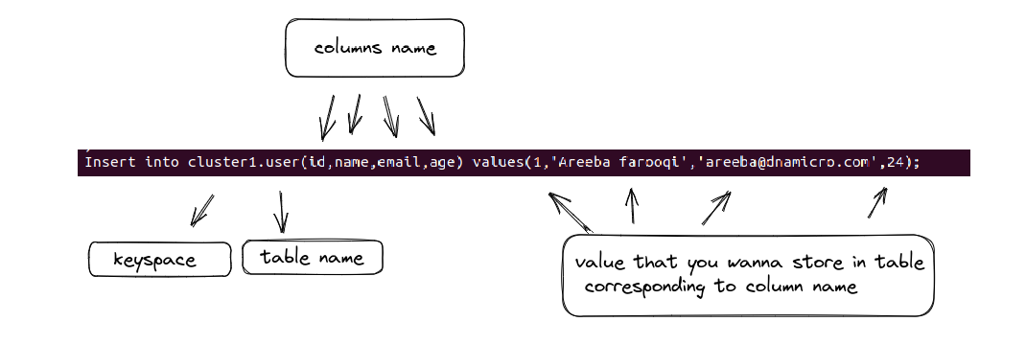

| Insert into cluster1.user(id,name,email,age) values(1,'Areeba farooqi','areeba@dnamicro.com',24); |
| --- |

If the query executed successfully then gonna see something like this

Here is the snapshot of the current database state.

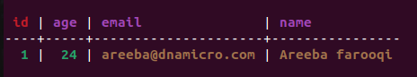

### **Update Operation**

The Cassandra Update query is used to update the data in the Cassandra table with the help of primary key

Syntex:

| Update KeyspaceName.TableName  Set ColumnName1=new Column1Value,  ColumnName2=new Column2Value,  ColumnName3=new Column3Value,  .  Where ColumnName=ColumnValue |
| --- |

### **Example**

Here is the screenshot that shows the database state before updating data.



Here is the snapshot of the executed Cassandra Update command that updates the record in the User table

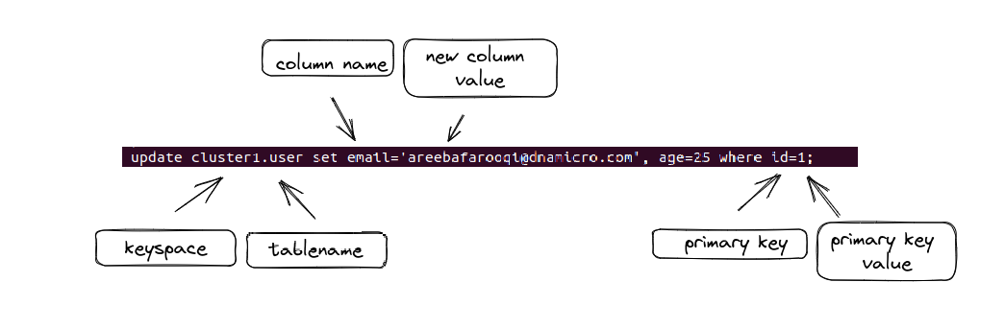

| update cluster1.user set email='areebafarooqi@dnamicro.com', age=25 where id=1; |
| --- |

If the query executed successfully then gonna see updated data like this

Here is the snapshot of the current database state.

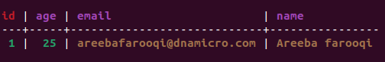

### **Delete Operation**

Command ‘Delete’ removes an entire row or some columns from the table Student. When data is deleted, it is not deleted from the table immediately. Instead deleted data is marked with a tombstone and are removed after compaction.

Syntex:

| Delete from KeyspaceName.TableName  Where ColumnName1=ColumnValue |
| --- |

### 

### **Example**

Here is the screenshot that shows the database state before updating data.

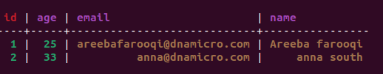

Here is the snapshot of the executed Cassandra delete into user table query that will delete one record in Cassandra table User.

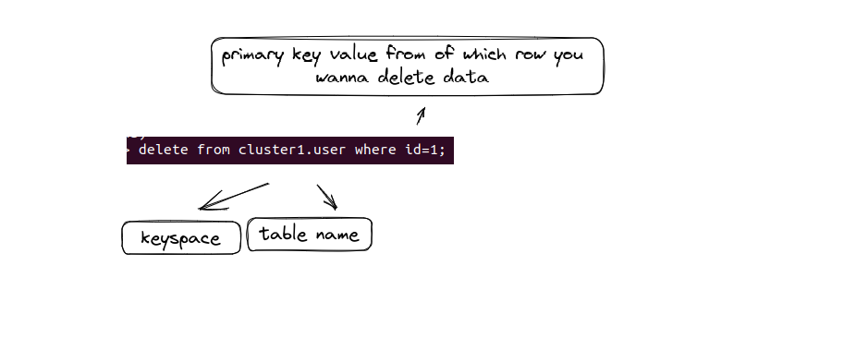

| delete from cluster1.user where id=1; |
| --- |

If the query executed successfully then gonna see updated data like this

Here is the snapshot of the current database state.

### 

### **Upsert Operation**

Cassandra does upsert. Upsert means that on updationCassandra will insert a row if a primary key does not exist already otherwise if primary key already exists, it will update that row.

Before updation

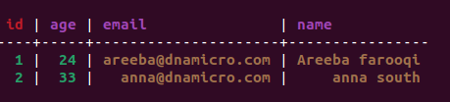

| update cluster1.user set email='elbert@dnamicro.com', age=25, name='elbert' where id=3; |
| --- |

### As there is no id=3 so it will insert a new row with id=3

After updation

